Nama : Nur Afalah

NIM : 20180801360

Fakultas : Ilmu Komputer

Jurusan : Teknik Informatika

SELECT *FROM FCUSTOMER_NOV

INSERT INTO FCUSTOMER_NOV

VALUES ('201','LARAS','RACHMA','WATI','JL ANGGREK','Q@GMAIL.COM','089765')

INSERT INTO FCUSTOMER_NOV

VALUES ('202','DJODY','REJA','KUSUMA','JL KENANGA','W@GMAIL.COM','08567')

INSERT INTO FCUSTOMER_NOV

VALUES ('203','RANGGA','RIZKI','KUSUMA','JL CITRA','S@GMAI.COM','08378')

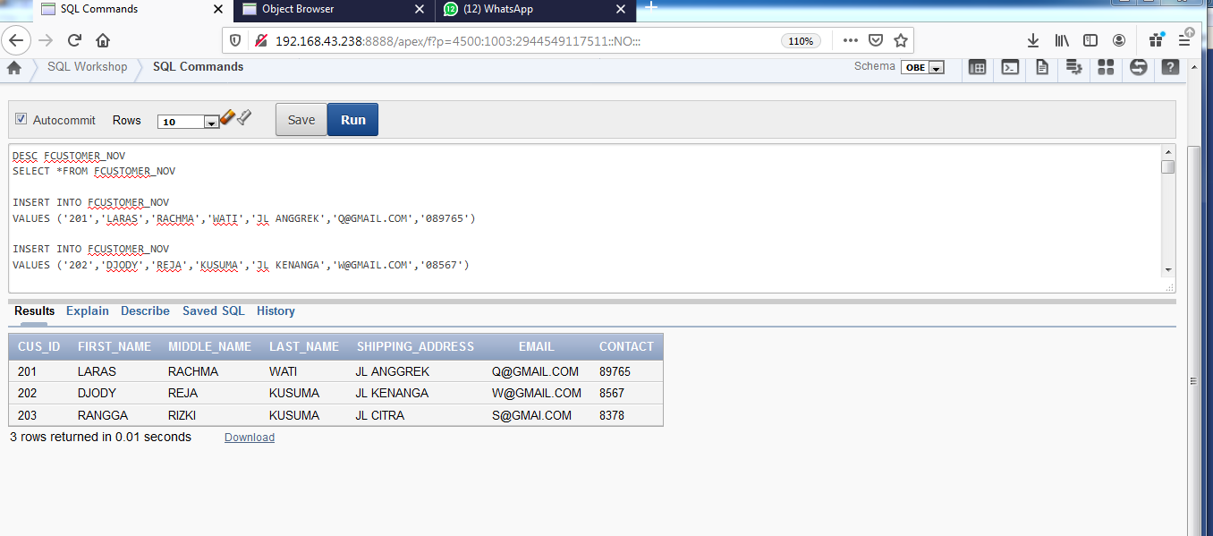

SELECT *FROM FORDER_NOV

INSERT INTO FORDER_NOV

VALUES ('01','201','05/09/0019','DELIVER')

INSERT INTO FORDER_NOV

VALUES (''02','202','06/07/0019','DELIVER')

INSERT INTO FORDER_NOV

VALUES (''03','203','09/07/0019','DELIVER')

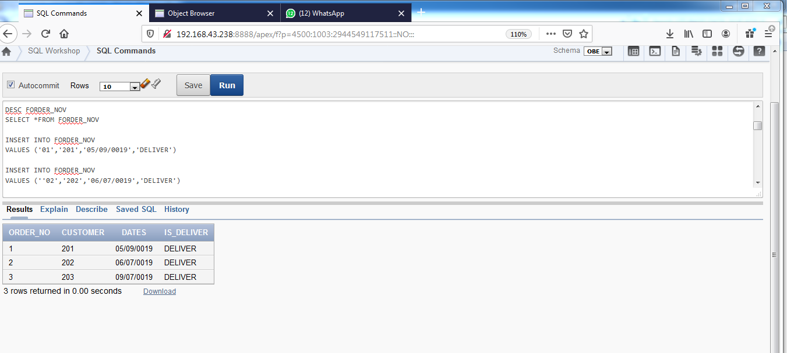

SELECT *FROM FORDER_DETALS_NOV

INSERT INTO FORDER_DETALS_NOV

VALUES('01','001','6')

INSERT INTO FORDER_DETALS_NOV

VALUES('02','002','5')

INSERT INTO FORDER_DETALS_NOV

VALUES('03','003','4')

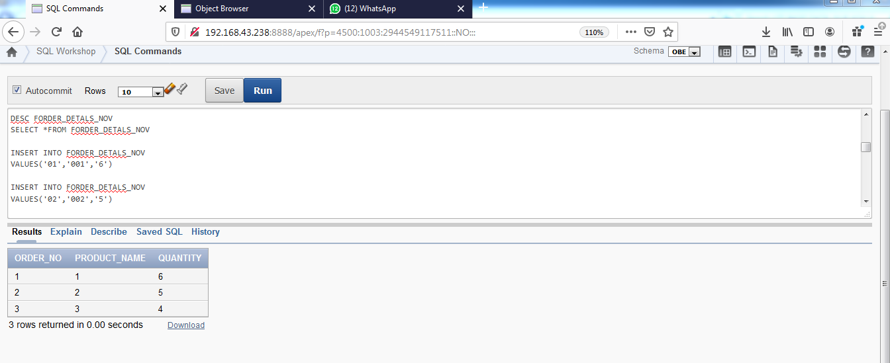

SELECT *FROM FPRODUCT_NOV

INSERT INTO FPRODUCT_NOV

VALUES('001','SEPATU','WANITA','40000','20000','-','')

INSERT INTO FPRODUCT_NOV

VALUES('002','IKAT RAMBUT','AKSESORIS','35000','23000','-','')

INSERT INTO FPRODUCT_NOV

VALUES('003','KERUDUNG','AKSESORIS','15000','10000','-','')

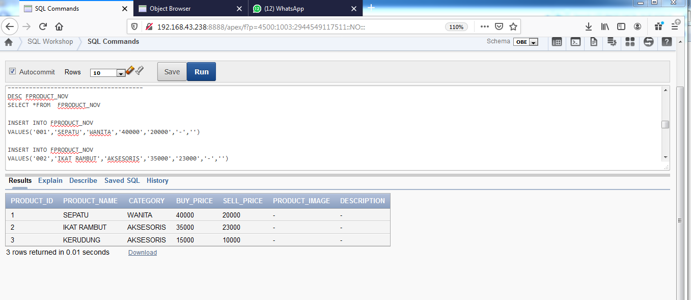

SELECT *FROM FSTOCK_NOV

INSERT INTO FSTOCK_NOV

VALUES('001','8','05/05/19','101')

INSERT INTO FSTOCK_NOV

VALUES('002','7','09/05/19','202')

INSERT INTO FSTOCK_NOV

VALUES('003','6','10/05/19','303')

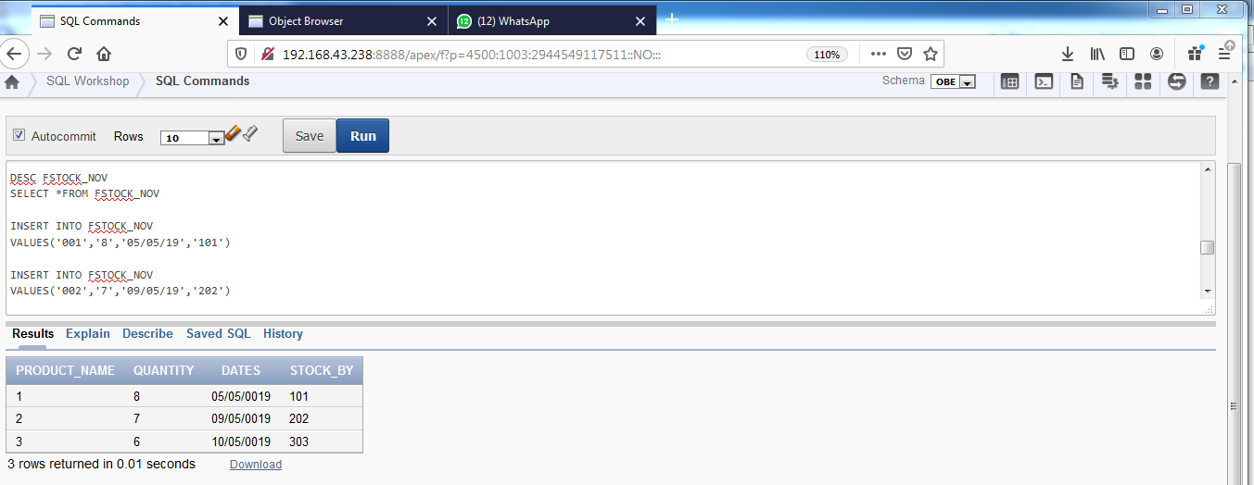

// jawaban No. 6

SELECT a.ORDER_NO, a.DATES, c.FIRST_NAME, b.PRODUCT_NAME, b.QUANTITY, d.SELL_PRICE,

b.QUANTITY*d.SELL_PRICE as total

FROM FORDER_NOV a, FORDER_DETALS_NOV b, FCUSTOMER_NOV c, FPRODUCT_NOV d

WHERE b.ORDER_NO = a.ORDER_NO and c.CUS_ID = a.CUSTOMER and b.PRODUCT_NAME = d.PRODUCT_ID

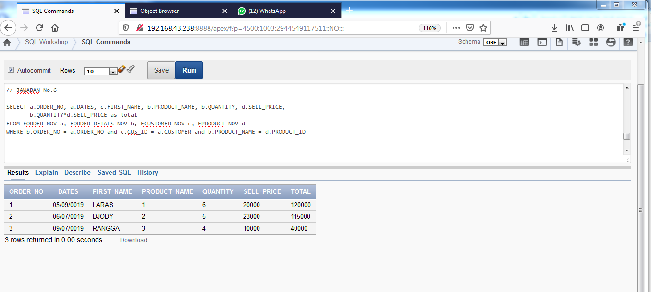

// JAWABAN No. 7

SELECT PRODUCT_NAME, sum(QUANTITY)

FROM FORDER_DETALS_NOV

GROUP by PRODUCT_NAME, QUANTITY

ORDER by quantity desc

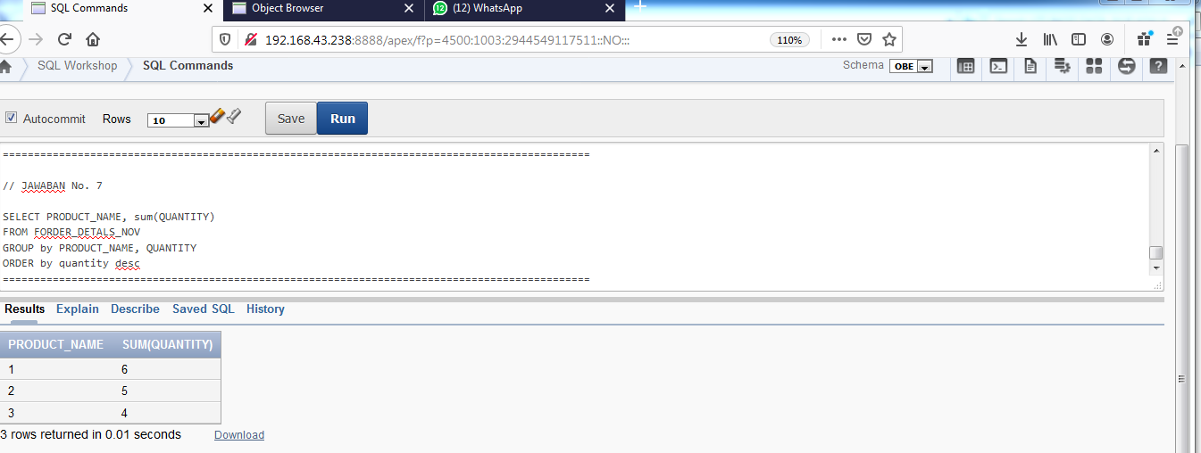

N0.8

SELECT a.DATE_ORDER,b.PRODUCT_NAME,sum(b.QUANTITY),

persentase = (sum(b.QUANTITY)/

SELECT sum(d.QUANTITY)

FROM FORDER_NOV c.ORDER_NO and c.ORDERDETAILS_NOV d

WHERE d.ORDER_NO = c.ORDER_NO and c.DATE = '2019-11-16)*100

FROM ORDER_NOV a, ORDERDETAILS_NOV b

WHERE b.ORDER_NO = a.ORDER_NO and a.DATE = '2019-11-16'

GROUP BY a.DATE_ORDER,b.PRODUCT_NAME,b.QUANTITY